**Output:**

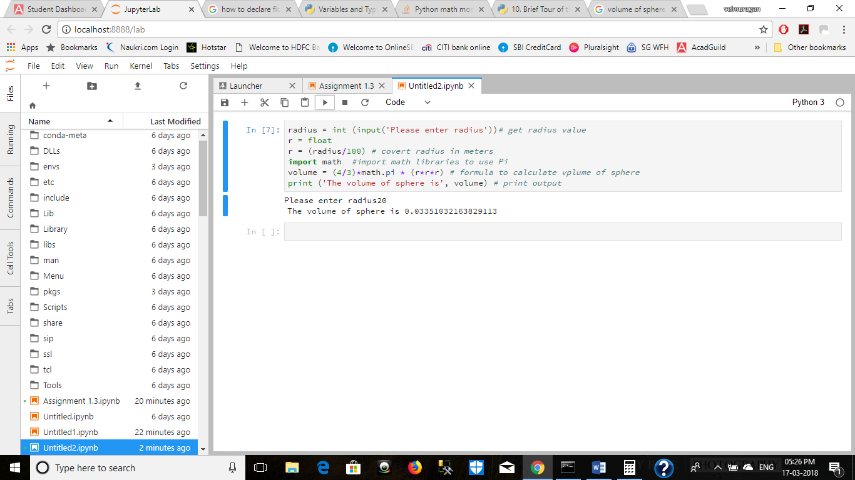

**Source code:**

radius = int (input('Please enter radius'))# get radius value

r = float

r = (radius/100) # covert radius in meters

import math #import math libraries to use Pi

volume = (4/3)*math.pi * (r*r*r) # formula to calculate vplume of sphere

print ('The volume of sphere is', volume) # print output